***1)How do you become a researcher / a research worker?***

Becoming a research has been about learning what I am most interested in, not as a job, but in life. Some parts of school have always felt like school…but some parts were really more like fun. For me, the fun was always about being outside and asking questions about how planet Earth works. Sometimes in class it might seem like we know everything about the world. But that is not true! There is so much we don’t know. Next time you are outside, think of all the questions you can ask about nature. I bet most of them do not have answers yet.

Then, as I finished high school and went to college, I only took the classes I was interested in. During every the summer holiday, I asked my professors where I could go to learn about how a lab works and what life as a scientist is really like. I did short internships all around the world to help me understand what it means to be a scientist. Then I just kept going and decided to do a PhD in Germany and then I found a job in the US after that. Making the decision of what to do next was always about asking the question “What questions will I be most satisfied asking?” “What environment do I care the most about” “How can I use my brain to make the world a better place?” And now I find myself here, studying the oceans.

***2) Have you already been to a plastic continent?***

I have been on the French ship, TARA, when it sailed from Chile to Easter Island, in the middle of the South Pacific. There we were looking for a plastic continent, but we did not find one. But that is a good thing! Here is a picture of me on TARA when I was looking at plastic collecting near Antarctica:

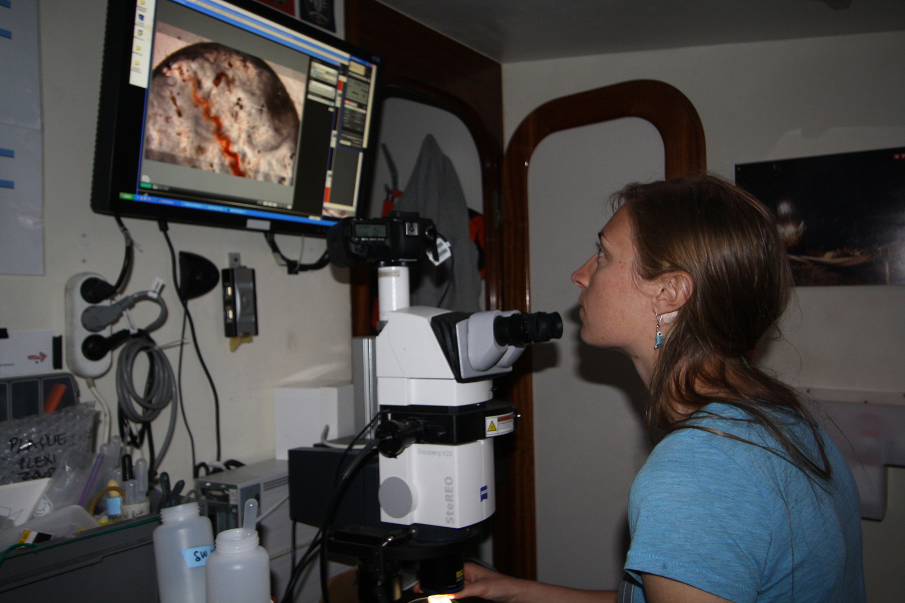

Soon I will take a ship to the North Pacific, where the biggest plastic continent is, we call it the “North Pacific Garbage Patch”. Other scientists have sent me plastic samples from there to study in the lab, but I have not been there yet myself.

***3) Why did all plastics gather in a continent?***

There are many ways plastic gets into the ocean. But humans can prevent all of it! Most rain that falls on the land drains to rivers and most rivers run to the ocean (unless they run to lakes). So most plastic garbage that humans leave on land will eventually flow with the water out to the ocean. Then there is all the plastic that people leave on the beach and A LOT of plastic that people throw off of ships. The biggest problem off ships is fishing ropes and nets from fishing boats. Then when all this plastic gets to the ocean, it starts to move with the ocean currents. If you look at a map of the world, you can find five big areas of water. These are called “gyres.” The water in gyres rotates and they act like a toilet when you flush it, except the water does not leave. So you can imagine that eventually all the plastic that enters the ocean and floats on the surface gets pulled into the gyres and is held there by the rotating water.

***4) How long does it take for a waste to reach the plastic continent?***

From the land to the plastic continent, it can take several years. Do you remember the earthquake and tsunami that happened in Japan last year? All the destruction caused a lot of plastic garbage to enter the ocean. Scientists have predicted how long it will take the plastic to cross the Pacific Ocean to the United States, then move into the gyre in the North Pacific between Hawaii and California, where the largest plastic continent is. Here are some images.

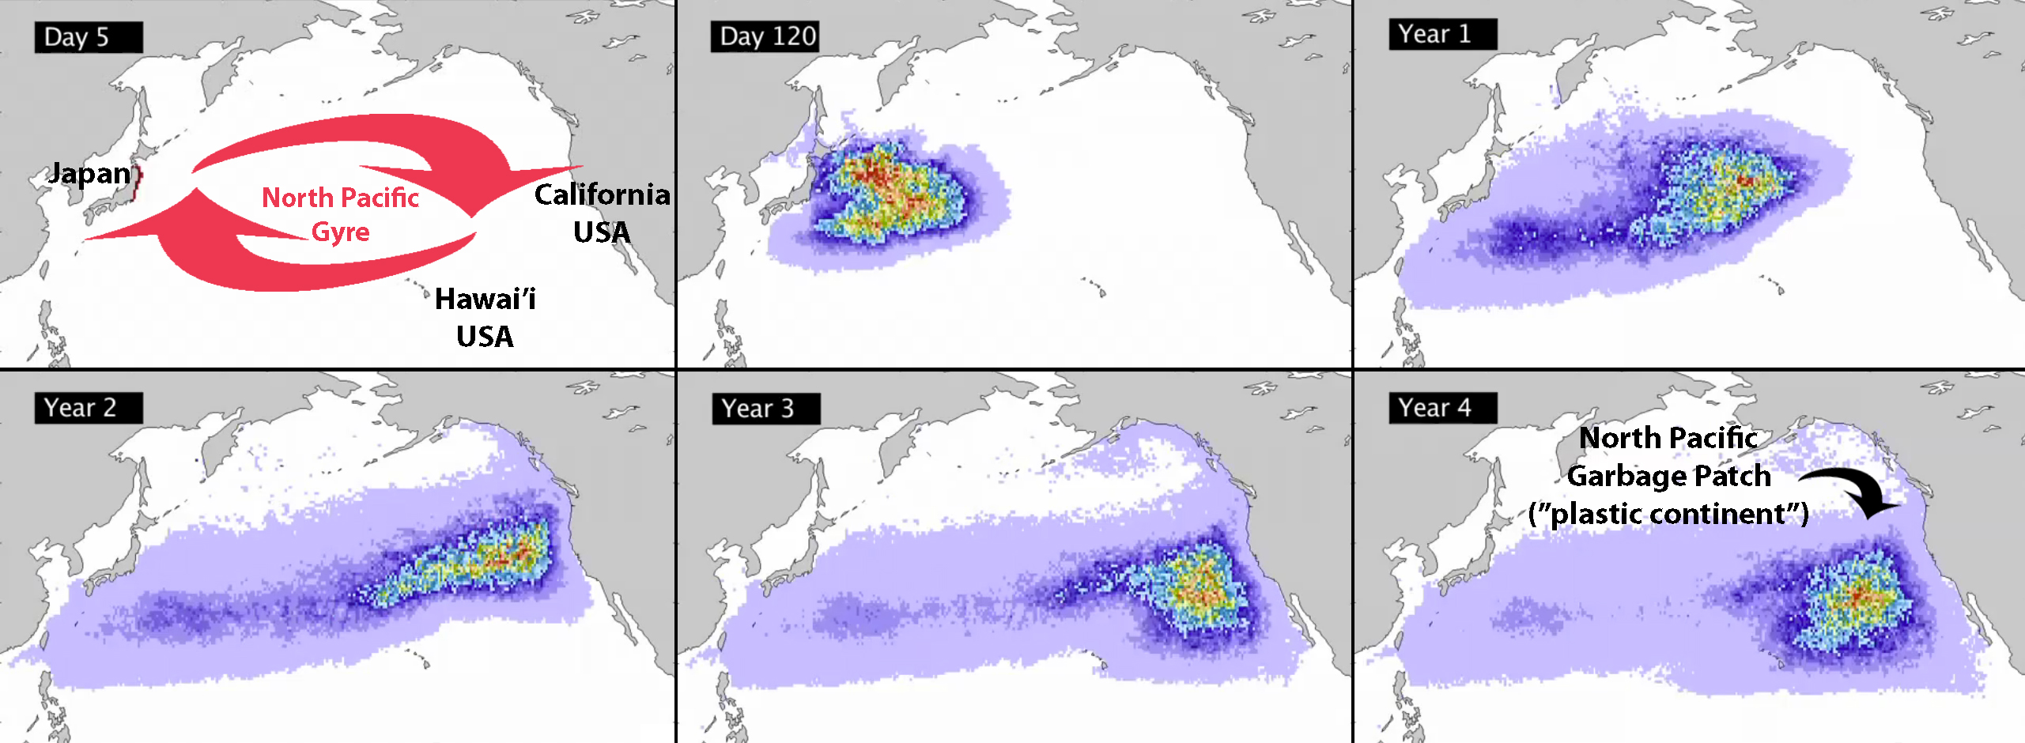

But once the plastic is there, it doesn’t go anywhere. The plastic put there today will be in the ocean much longer than any of us will be alive.

***5) Can we destroy the plastic continent? for example with the help of aquatic tractors or by recycling,***

At this point, engineers have decided that the plastic continent in the North Pacific is too large to collect. It would be too expensive and there is no country or group willing to pay for the problem. Since it is a problem of the whole planet, who do you think should be responsible for cleaning it?

What we CAN do is prevent the plastic continent from getting bigger. We can do this by making sure that not one more piece of plastic enters the oceans. That means use less plastic! Think of all the plastic you use in your daily lives: packaging when you buy something new, bags, plastic silverware. Carry real silverware and a water bottle in your bag or purse so you do not need to use plastic silverware or buy plastic bottles of water. And tell your parents to do the same thing. ☺ Every time you make a decision to not use plastic, you are helping the planet. Another way to prevent the plastic continent from getting bigger is to clean up the land so that plastic does not run out to the oceans. Pick a day when you and your friends go around outside or to a beach and collect as much plastic as you can find. Put this in the garbage where it can go to a landfill instead of the ocean. We can still change our planet for the future.

***6) Does the plastic continent move around? can it reach France?***

The plastic continent does move around, but not fast and not far. It stays in the same general area in the middle of the ocean because of the circulating water of the North Pacific Gyre (or any gyre, if it is in another part of the globe). It will not reach France, but some day it may affect your life in France. Read the next section to understand how.

***7) Can fishes die in the plastic continent? is it possible that fishes die , what about human beings ? why?***

Fish and other animals, especially birds and sea turtles, die all the time because of the plastic in their ocean homes. To them, plastic looks colorful, like food. Look at this picture of a baby bird from Hawai’i. This is all the plastic that was found in its belly after it died. Next to it is small fish collected from the North Pacific plastic continent that was found with many pieces of plastic in its belly too.

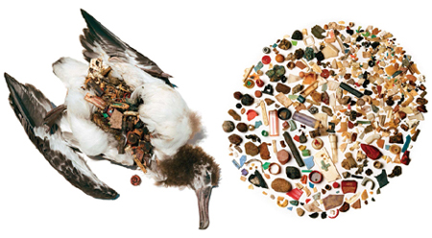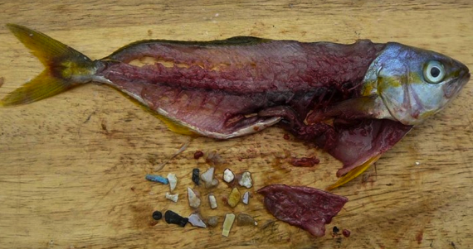

Another bad effect of the plastic in the ocean is that plastic acts like a magnet and attracts dangerous chemicals that are in the water at low concentrations. That means when animals eat the plastic, they are also eating these poisonous chemicals, which build up in their muscles and fat to high concentrations. This might be dangerous for humans, because fish from the ocean are an important food source for us. Scientists are just beginning to study this problem to understand the risks that exist for us. But overall, it is a basic equation: the trash and pollution we let go to the environment share the same planet as us, it does not disappear; it will always affect us in some way.

***8) Are the zooplancton and the phytoplancton contaminated?***

Right now we do not know how zooplankton and phytoplankton are affected by the plastic continent. That is a good question! How do you think they might be affected?

***9) What are the living things that we can find on the plastic continent?***

Have you ever been to the beach and explored the rocks on the coast? Have you seen all the life that lives on the rocks? There are snails, barnacles, mussels and other shellfish, starfish, many types of algae and seaweed, and small fish that live in the cracks. These are all the animals you find living on plastic in the plastic continent. As the animals grow, they sometimes grow around the plastic and the plastic becomes part of them. Here are a few examples of that: a turtle that got stuck in a piece of plastic when it was small grew into the plastic ring; a barnacle living on plastic from fishing ropes also grew around it so that plastic became part of its shell.

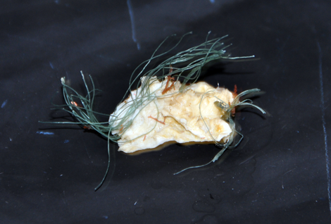

There are also many organisms living on the plastic that we can only see with a microscope, these are called “microbes”, such as bacteria and viruses. We do not yet know the role of these microbes and what they do with the plastic. Microbes are able to do amazing things. They have very interesting metabolisms. They can live in places too extreme for humans, such as in battery acid and near ocean volcanoes that are 3 km under the ocean. They also “eat” extreme things, such as rocks and minerals and even dangerous chemicals. They are able to clean up environmental problems. For instance, after the massive oil spill in the Gulf of Mexico in 2010, the microbes that lived there began eating the oil immediately.

***10) What do you search? / what are you looking for ?***

The question I am asking and trying to learn in the lab is “what are the microbes doing on the plastic in the plastic continent?” “Are they able to eat the chemicals on the plastic?” “Are they even able to eat some types of plastic in the plastic continent?” I DO know that if there are microbes eating the plastic, they can do it only *very* slowly. They will not solve the problem of the plastic continent. Only humans can act on a large enough scale to prevent the plastic continent from growing.

***11) Can new species be created from plastic?***

The plastic will not create new species, but existing species might be able to develop new ways to deal with the plastic, either by avoiding it or by finding new chemical reactions that will help break down the plastic that they can use for energy. Microbes are the most likely type of organisms that will develop these traits. They have very short lives (1-2 days in the surface ocean), which means they can evolve quickly to new environments. Only more research in this area will teach us more!